# DBMS SQL QUERY 3

**MERGE:**

MERGE INTO EMPLOYE1 e USING JOB1 j

ON (e.EMP_ID = j.JOB_ID)

WHEN MATCHED THEN UPDATE

SET

e.EMP_NAME = j.JOB_NAME,

e.EMP_DEP = j.JOB_QUALIFICATION

WHEN NOT MATCHED THEN INSERT

VALUES(j.JOB_ID, j.JOB_NAME, j.JOB_QUALIFICATION);

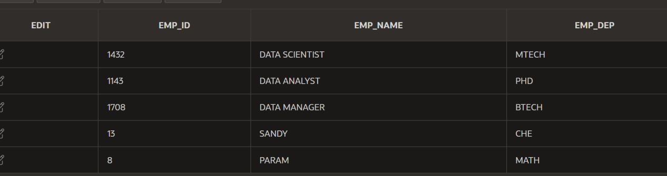

**SEQUENCE:**

CREATE SEQUENCE sequence_1

INCREMENT BY 1

START WITH 1

MAXVALUE 50000

NOCACHE

NOCYCLE;

SELECT sequence_name, min_value, max_value, increment_by,

last_number

FROM user_sequences;

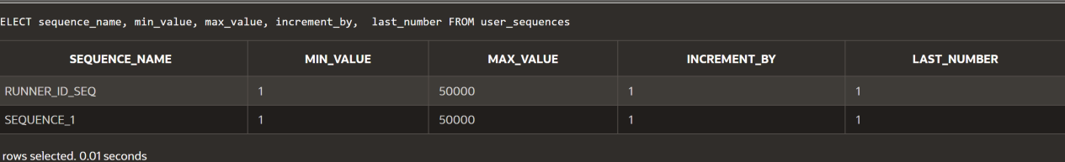

CREATE TABLE students

(

ID number(10),

NAME char(20)

);

INSERT into students VALUES

(sequence_1.nextval,'Shubham');

INSERT into students VALUES

(sequence_1.nextval,'Aman');



**USING FUNCTIONS:**

* **FACTORIAL**

DECLARE

num number;

factorial number;

FUNCTION fact(x number)

RETURN number

IS

f number;

BEGIN

IF x=0 THEN

f := 1;

ELSE

f := x * fact(x-1);

END IF;

RETURN f;

END;

BEGIN

num:= 5;

factorial := fact(num);

dbms_output.put_line(' Factorial '|| num || ' is ' || factorial);

END;

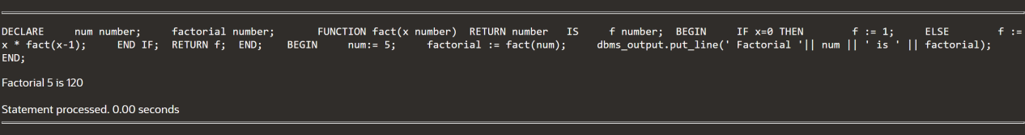

* **FIND MAX:**

DECLARE

a number;

b number;

c number;

FUNCTION findMax(x IN number, y IN number)

RETURN number

IS

z number;

BEGIN

IF x > y THEN

z:= x;

ELSE

Z:= y;

END IF;

RETURN z;

END;

BEGIN

a:= 23;

b:= 45;

c := findMax(a, b);

dbms_output.put_line(' Maximum of (23,45): ' || c);

END;

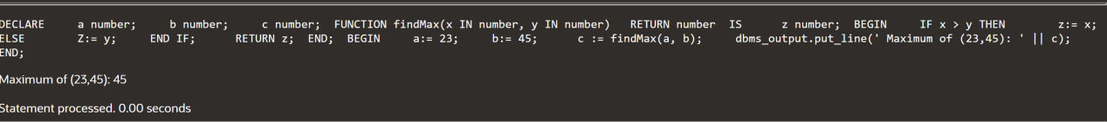

**MERGE:**

MERGE INTO BONUSES b

USING employe e

ON (b.employee_id=e.employee_id)

WHEN MATCHED THEN

UPDATE SET b.bonus=e.salary*.05;



**SELECT:**

* DECLARE

E_EID EMPLOYEEE.E_ID%TYPE;

E_DEP_ID EMPLOYEEE.DEP_ID%TYPE;

BEGIN

SELECT E_ID,DEP_ID

INTO E_EID,E_DEP_ID

FROM EMPLOYEEE

WHERE LAST_NAME='PARAM';

DBMS_OUTPUT.PUT_LINE('E_ID OF EMPLOYEE IS: '||E_EID);

DBMS_OUTPUT.PUT_LINE('DEPARMENT ID ID: '||E_DEP_ID);

END;

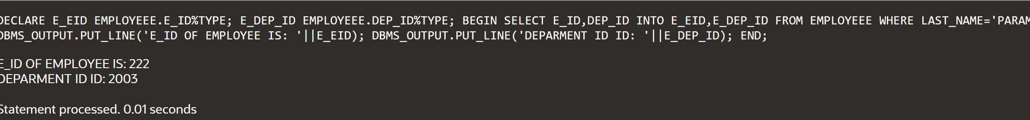

* DECLARE

E_EID EMPLOYEEE.E_ID%TYPE;

E_DEP_ID EMPLOYEEE.DEP_ID%TYPE;

BEGIN

SELECT E_ID,DEP_ID

INTO E_EID,E_DEP_ID

FROM EMPLOYEEE

WHERE LAST_NAME='PARAM';

DBMS_OUTPUT.PUT_LINE('E_ID OF EMPLOYEE IS: '||E_EID);

DBMS_OUTPUT.PUT_LINE('DEPARMENT ID ID: '||E_DEP_ID);

END;

* DECLARE

S_SUM NUMBER(10);

S_DEPT NUMBER NOT NULL:=4;

BEGIN

SELECT SUM(SALARY)

INTO S_SUM FROM EMPLOYEE

WHERE FIRST_NAME=’DHIVYA’;

DBMS_OUTPUT.PUT_LINE('SUM OF THE SALARY: '||S_SUM);

END;

* DECLARE

LAST_NAME STUD.LAST_NAME%TYPE :='JOSHUA';

BEGIN

DELETE FROM STUD WHERE LAST_NAME=LAST_NAME;

END;